Rabbit MQ with Spring Boot
--------------------------------------------------
What is RabbitMQ?
RabbitMQ = Open-source Message Broker / Message Queue System
a middleware server that receives messages from producers and delivers them to consumers using queues and exchanges.
✅ Protocols Used by RabbitMQ (VERY IMPORTANT)
🟢 1️⃣ AMQP (Advanced Message Queuing Protocol) ⭐ MAIN PROTOCOL
👉 Default and primary protocol used by RabbitMQ.
used port 5672
🔵 2️⃣ MQTT
Lightweight messaging protocol.
🟡 3️⃣ STOMP
Simple Text Oriented Messaging Protocol
🟠 4️⃣ HTTP (Management Plugin)
RabbitMQ supports HTTP for
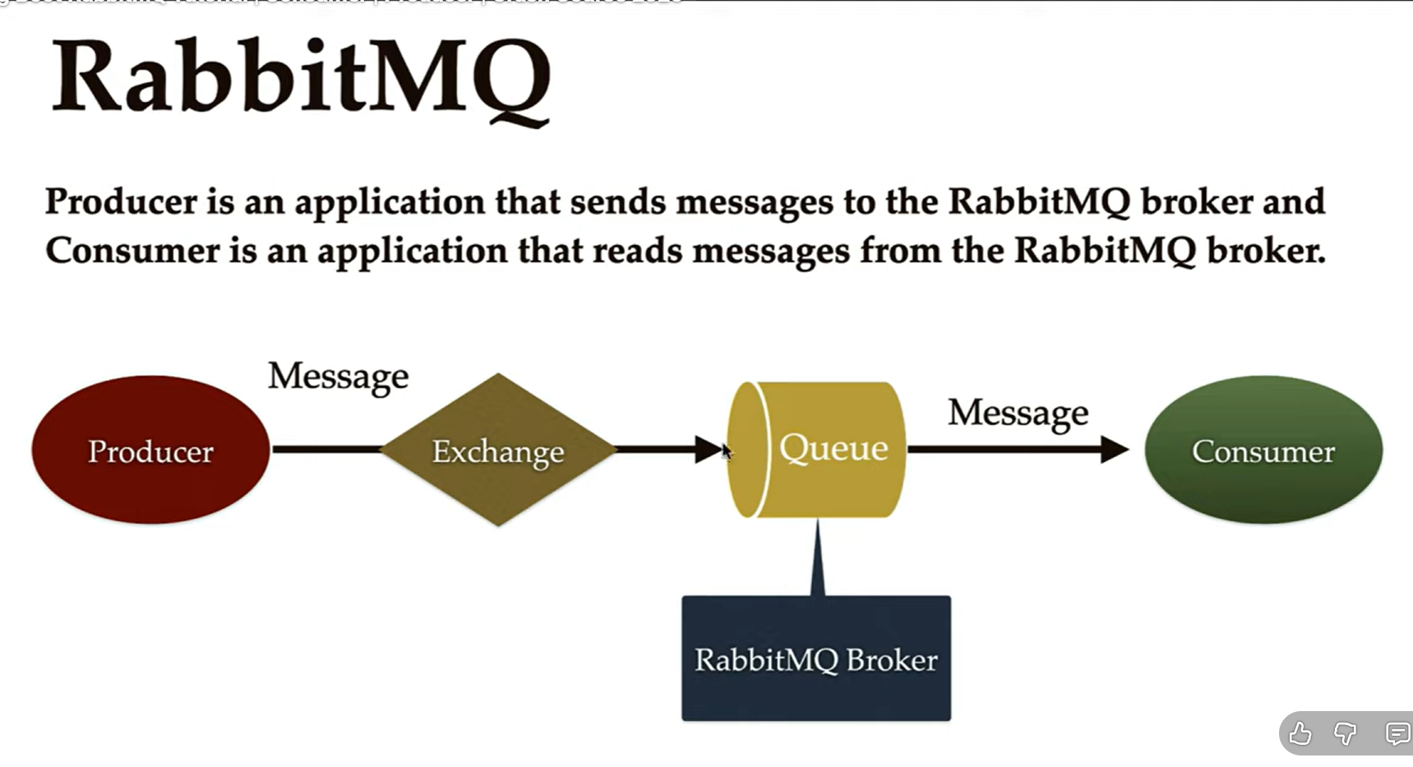
Producer will produce a message and sends to the exchange and exchange will use some rules and sends the message to the queue and consumer will read the message from the queue

✅ 1️⃣ Producer
👉 Producer = the application/service that creates and sends a message.
A producer is an application or service that creates and sends messages to the messaging system.
It publishes messages to an exchange, not directly to a queue.
✅ Exchange
An exchange is a message routing component in RabbitMQ that receives messages from producers and decides which queue(s) should get the message based on routing rules and bindings.
It does not store messages
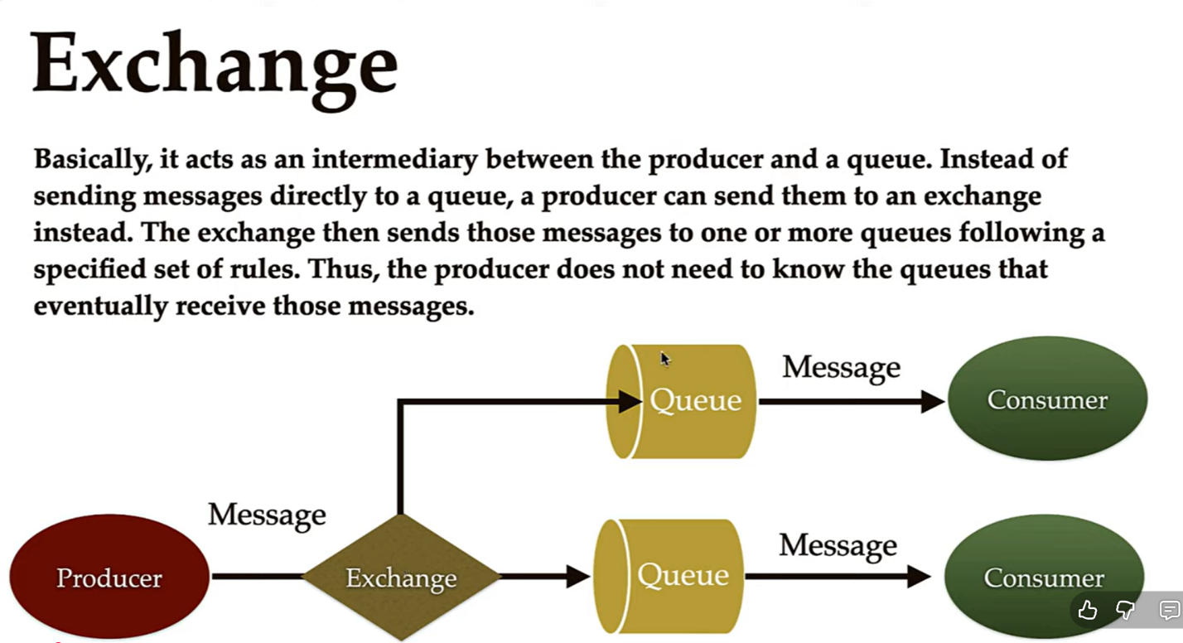

✅ Queue
A queue is a storage buffer inside the message broker that holds messages until a consumer retrieves and processes them.
Messages stay in the queue until they are consumed or expired.
✅ Consumer
A consumer is an application or service that listens to a queue, receives messages from it, processes them, and sends acknowledgement after successful processing.
✅ 1️⃣ Routing Key
A routing key is a string label attached to a message by the producer, used by the exchange to decide which queue should receive the message.
It acts like an address / category / tag for the message.
📌 Who sets routing key?
👉 Producer sets it while sending message.
EX:-
Message: "Order Created"
Routing Key: order.created

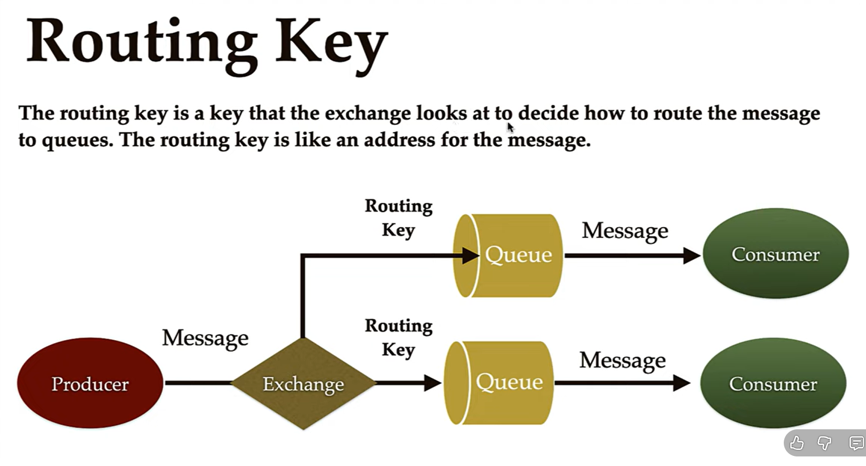
✅ 2️⃣ Binding
📌 Definition
A binding is a rule or connection between an exchange and a queue, which tells the exchange:
👉 which routing keys should send messages to which queue.
Without binding:
❌ exchange cannot send message to queue.
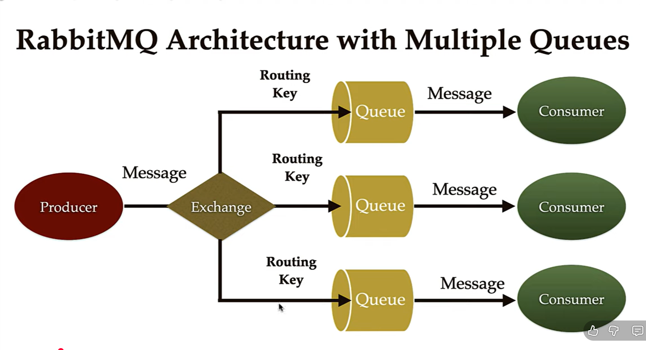

Rabbit Mq With Spring Boot
✅ PART 1 — RabbitMQ with Exchange + Routing Key (REAL WORLD METHOD)
👉 Used in microservices communication.
🧩 STEP 1 — Add Dependency
<dependency>
<groupId>org.springframework.boot</groupId>
<artifactId>spring-boot-starter-amqp</artifactId>
</dependency>

⚙️ STEP 2 — application.yml
spring:
rabbitmq:
host: localhost
port: 5672
username: guest
password: guest

🧱 STEP 3 — Create RabbitMQ Config Class
@Configuration
public class RabbitMQConfig {

📦 STEP 4 — Define Queue Bean
@Bean
public Queue myQueue() {
return new Queue("order.queue");
}

🔁 STEP 5 — Define Exchange Bean
@Bean
public DirectExchange myExchange() {
return new DirectExchange("order.exchange");
}

🔗 STEP 6 — Create Binding Bean
@Bean
public Binding binding(Queue myQueue, DirectExchange myExchange) {
return BindingBuilder
.bind(myQueue)
.to(myExchange)
.with(ROUTING_KEY);
}

If you don’t want exchange and routing key you can just create the queue and publish message

🧠 Sending JSON Objects in RabbitMQ with Spring Boot — 2 Ways
✅ WAY 1 — Using Spring MessageConverter (🔥 Industry Standard)
Spring automatically converts Java Object to the Json using Jakson2JsonMessageConverter

Strps:-
Configure Message Converter
@Configuration
public class RabbitConfig {

@Bean
public MessageConverter converter(){
return new Jackson2JsonMessageConverter();
}
}

⚙️ What Happens Internally
Event Object
↓
Jackson2JsonMessageConverter
↓
JSON + metadata headers
↓
RabbitMQ
↓
Listener Container
↓
Converter
↓
Event Object injected

✅ Advantages
- clean code
- no manual parsing
- type safe
- less boilerplate
- works with @RabbitListener
- automatic metadata handling
- industry standard

❌ Disadvantages
- Spring dependent
- less manual contro
✅ WAY 2 — Manual JSON Conversion using ObjectMapper
👉 You convert object → JSON string manually.

🔧 STEP 1 — Producer
@Autowired
private ObjectMapper objectMapper;

public void send(Event event) throws Exception {

String json = objectMapper.writeValueAsString(event);

rabbitTemplate.convertAndSend(
"event.exchange",
"event.key",
json);
}

🔧 STEP 2 — Listener
@RabbitListener(queues="event.queue")
public void listen(String json) throws Exception {

Event event =
objectMapper.readValue(json, Event.class);

System.out.println(event.getId());
}

⚙️ Internal Flow
Event Object
↓
ObjectMapper
↓
JSON String
↓
RabbitMQ
↓
Listener
↓
ObjectMapper
↓
Event Object

✅ Advantages
- full control
- framework independent
- useful in non-spring apps
- useful in polyglot systems

❌ Disadvantages
- repetitive conversion code
- more boilerplate
- no metadata headers
- no automatic type handling
- more bugs in large systems

🏢 Which One is Best in Industry ?
🥇 MessageConverter Method
Used in:
- enterprise spring boot apps
- microservices
- event-driven architecture
- production systems
Because:
cleaner
less code
easier maintenance
better integration
type safe

🥈 ObjectMapper Method
Used in:
- legacy systems
- raw rabbitmq client usage
- mixed tech stack messaging
- non-spring apps

🧠 REAL INDUSTRY RULE
Spring Boot + RabbitMQ → use Jackson2JsonMessageConverter
Manual conversion only when:
- cross-language messaging needs special format
- custom schema transformation
- performance tuning edge cases

🔥 VERY IMPORTANT BONUS TIP (Senior Level)
Even in converter approach:
industries often send wrapper like:
public class EventWrapper<T>{
private String type;
private T payload;
}
instead of raw objects.
Used for:
- versioning
- schema evolution
- multi-event queues

🥇 RabbitMQ Message Acknowledgement (ACK / NACK) — Complete Notes

✅ 1. What is Message Acknowledgement ?
👉 Definition
Message Acknowledgement is the process where consumer tells RabbitMQ whether message processing is successful or failed.
After sending message to consumer, RabbitMQ waits for response:
- ✔ ACK → message processed successfully → remove from queue
- ❌ NACK / Reject → processing failed → decide requeue or discard
👉 Without ACK → RabbitMQ assumes message not completed.

✅ 2. Why ACK is Needed ?
Without acknowledgement:
- Message loss can happen
- System can't know processing result
- Crash during processing = message gone
With acknowledgement:
- Reliable processing
- Retry mechanism
- Failure handling
- Exactly once / at least once delivery patterns

✅ 3. Message Flow With ACK
Step-by-step Flow
1️⃣ Producer sends message
2️⃣ Exchange routes message
3️⃣ Queue stores message
4️⃣ Consumer receives message
5️⃣ Consumer processes message
6️⃣ Consumer sends ACK / NACK

📌 Diagram Flow (logical)
Producer → Exchange → Queue → Consumer
↓
ACK / NACK

✅ 4. Types of Acknowledgements

✔ AUTO ACKNOWLEDGE
RabbitMQ automatically considers message success after delivery.
acknowledge-mode = AUTO
👉 Risk:
- Consumer crash → message lost
👉 Use only when:
- Non critical data
- Logging
- Notifications

✔ MANUAL ACKNOWLEDGE (Most Important)
Consumer explicitly sends ACK.
acknowledge-mode = MANUAL
👉 Best practice for production systems.

✅ 5. Types of Consumer Responses

🟢 ACK (BasicAck)
Message successfully processed.
basicAck(tag, multiple)
multiple=false
ack only this message.
channel.basicAck(deliveryTag, false);
👉 Message removed from queue.

🔴 NACK (BasicNack)
Processing failed.
basicNack(tag, multiple, requeue)
requeue=true
→ put message back into queue.

requeue=false
→ send to DLQ or discard.
channel.basicNack(deliveryTag, false, true);
Third parameter = requeue
- true → retry message
- false → discard / DLQ

⚠ REJECT (BasicReject)
Reject single message.
channel.basicReject(deliveryTag, false);
Similar to NACK but limited control.

✅ 6. Spring Boot Example (Manual ACK)

Step 1 — Listener Configuration
spring.rabbitmq.listener.simple.acknowledge-mode=manual
or
spring:
rabbitmq:
listener:
simple:
acknowledge-mode: manual

Step 2 — Consumer Example
@RabbitListener(queues = "order.queue")
public void consume(Message message, Channel channel) throws Exception {

long deliveryTag = message.getMessageProperties().getDeliveryTag();

try {
String body = new String(message.getBody());

System.out.println("Processing: " + body);

// business logic success
channel.basicAck(deliveryTag, false);

} catch (Exception ex) {

// processing failed
channel.basicNack(deliveryTag, false, true);
}
}

✅ 7. ACK vs NACK vs REJECT
Feature | ACK | NACK | REJECT
Success | ✔ | ❌ | ❌
Multiple messages | ✔ | ✔ | ❌
Requeue support | ❌ | ✔ | ✔
Recommended | ✔ | ✔ | ⚠ Rare

✅ 8. Delivery Tag — Important Concept
RabbitMQ gives each message a:
deliveryTag
👉 Unique identifier for that message in channel.
Used for:
basicAck()
basicNack()
basicReject()

✅ 9. What Happens If Consumer Crashes ?
If:
- Manual ACK enabled
- ACK not sent
👉 RabbitMQ automatically:
- requeues message
- sends to another consumer
This gives fault tolerance.

✅ 10. Real Production Example
Order Processing System:
- Consumer receives order
- Payment API called
- Inventory updated
If payment fails:
NACK with requeue
If inventory invalid:
NACK without requeue → Dead Letter Queue
If everything success:
ACK

✅ 11. Best Practices (Very Important)
✔ Always use manual ACK in production
✔ Use DLQ for failed messages
✔ Avoid infinite retries
✔ Implement retry count header
✔ Use idempotent processing
✔ Handle exceptions properly

✅ 12. Common Mistakes Developers Make
❌ Using AUTO ack for critical systems
❌ Forgetting ACK → queue stuck
❌ Infinite requeue loops
❌ Blocking consumers
❌ Not using DLQ

DLX & DLQ (RabbitMQ)
🧠 1️⃣ What is DLQ ?
✅ Definition
Dead Letter Queue (DLQ) is a special queue where messages are sent when they cannot be processed successfully by consumers.

failed / rejected / expired messages → DLQ
✅ Why DLQ Exists ?
Without DLQ:
❌ message lost
❌ infinite retries
❌ system crashes
With DLQ:
✔ failure tracking
✔ retry later
✔ debugging
✔ alerting
🧠 2️⃣ What is DLX ?
✅ Definition
Dead Letter Exchange (DLX) is an exchange that receives messages that are dead-lettered from a queue.
Normal flow:
Producer → Main Exchange → Main Queue → Consumer

With DLQ:
Producer → Main Exchange → Main Queue → Consumer (FAIL)
↓
Dead Letter Exchange
↓
Dead Letter Queue

✅ Minimum Things Required For DLQ
🟢 Main Components (Normal Flow)
Component Example
Main Exchange order.exchange
Main Queue order.queue
Routing Key order.key

🔴 DLQ Components (Failure Flow)
Component Example
Dead Letter Exchange order.dlx
Dead Letter Queue order.dlq
DLQ Routing Key order.dlq.key

✅ ACK / NACK → Consumer level decision
Used to say:
👉 “I processed the message”
👉 “I failed to process now — try again”
This is runtime handling.

✅ DLX / DLQ → Broker level failure handling
Used to say:
👉 “This message is permanently problematic”
👉 “Move it away from main queue”
This is failure management + isolation.

